**[ChNum]**

**[ChTitle]**

**[Author Name(s)]**

**[Author Affiliaton(s)]**

**Please add the names, and affiliations**

**[NON PRINT ITEMS]**

**Abstract:**

This chapter presents the contactless vital sign monitoring through Continuous-waves (CW) radar sensor. The chapter is mainly divided into two parts, contactless vital sign monitoring through CW radar sensor and contactless vital sign monitoring through frequency-modulated Continuous-waves (FMCW) radar sensor. The theory and signal processing algorithm of the radar are introduced. The architectures of the CW/FMCW radar systems are simple, which facilitates the integration of radar technology into compact devices. Commercial CW/FMCW radar front-end transceivers are widely provided. With the advantage of strong environmental adaptability, low power consumption, penetrability, CW/FMCW radars are promising for contactless vital sign monitoring application. This chapter introduces their potential application in cardiopulmonary monitoring, human gait recognition, cancer medical application, indoor human tracking.

**Key Words:**  **radar, CW, FMCW, cardiopulmonary monitoring, human gait recognition, cancer medical application,** **indoor human tracking**

# Radar based vital sign monitoring

1. Introduction

Vital sign monitoring has become hot research topic in the fields of consumer electronics, biomedical applications, and through-wall detections. In these application scenarios, mainstream solutions include contact-based sensors, camera-based solutions, and microwave radar systems.

For contact-based sensor, its advantages and disadvantages come from its own characteristics: it needs to be in contact to take effect. Therefore, wearing for a long time or requiring frequent contact will bring uncomfortable feeling to the user, which greatly reducing the convenience of the sensors. For camera-based solution, its advantage is that it has a wide range of uses, and tracking and detecting objects is more intuitive. But it also has disadvantages: 1) It is extremely dependent on light. When the light conditions are not good or there is interference from other light sources, the imaging ability drops rapidly. 2) It cannot penetrate objects. When there is an obstacle between the camera and the target, the camera-based solution is completely ineffective. 3) Most camera-based solutions can only provide two-dimensional image information. Even if some cameras can provide depth information [1][2], there is still no method that can better distinguish between people and other static objects.

Compared with conventional contact-based sensors and camera-based solutions, microwave radar systems have their own natural advantages. First, the microwave radar system is a contactless solution and therefore has good convenience in use. Second, microwave radar systems do not depend on light and can penetrate obstacles well [3]-[5]. More importantly, radar sensors are more sensitive to small movements. Based on Doppler and micro-Doppler characteristics, radar sensors can obtain very small movements of target objects such as human respiration and heartbeat [6]-[9].

Continuous-wave (CW) radar has the advantages of low transmit power, high sensitivity and simple structure. Therefore, it is widely used in various fields. Typically, CW radars are divided into two categories: 1) unmodulated CW systems and 2) modulated CW solutions. A typical example of an unmodulated continuous wave system is an interferometer (Doppler) radar [10][11], which operates on a single-tone CW to obtain the target's phase history. In addition, this kind of radar has high accuracy in displacement and velocity measurement [4][6][12]. However, it is difficult for CW radar to obtain the absolute range information of the target. Modulated continuous wave radar includes frequency shift keyed radar [13], stepped frequency continuous wave radar [14] and frequency modulated continuous wave (FMCW) radar [15]-[21]. As one of the most popular types, FMCW radar can easily and accurately obtain the accurate distance information of the target. In addition, if the coherence of the system is achieved, FMCW radar can extract Doppler information related to the radial velocity of the target and measure the displacement of the target. However, the hardware and signal processing of the FMCW system to measure range profile is much more complicated than the hardware and signal processing of the unmodulated CW system. Moreover, the displacement accuracy of the FMCW radar may not be as good as that of the unmodulated CW system, which can easily achieve sub-millimeter accuracy [15]. By making the radar coherent, the phase history of the target can be preserved during the coherent processing interval (CPI), so that Doppler information can be derived, which provides two dimensions: distance and Doppler. This two-dimensional information can help isolate the required moving target from the surrounding static clutter, thereby achieving the detection of vital signals.

1. Vital sign monitoring through Continuous-Wave radar

2.1 Theory

2.1.1 Basic theory

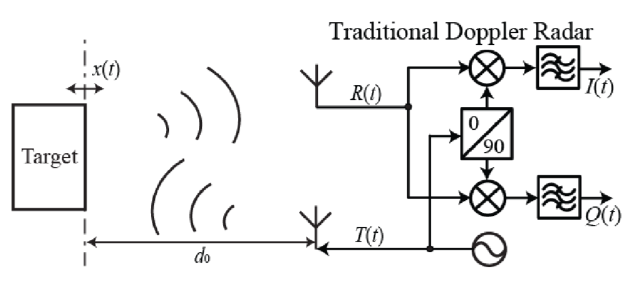

Fig.1 Common configuration of CW radar [1]

Figure 1 shows the block diagram of a common CW radar. As shown in Fig.1, CW radar detects the movements of the target by transmitting a single-tone electromagnetic wave to the target and receives the reflected signal, which modulates the motion information of the target. The theory is detailed as follows.

$T\left(t\right)$ is modeled as [1]:

$$\begin{aligned}T\left(t\right)=\exp\left(j\left(2πf_{c}t+φ_{0}\right)\right)\#\left(2.1\right),\end{aligned}$$

where $f_{c}$ is the frequency of $T\left(t\right)$, $φ_{0}$ is the initial phase.

The reflected signal $R(t)$ is:

$$\begin{aligned}R\left(t\right)=ρT\left(t-∆t\right)\#\left(2.2\right)\end{aligned},$$

where $ρ$ is the propagation loss and $∆t$ is the time interval of the signal from the transmitting (TX) antenna to the receiving (RX) antenna. $∆t=\frac{2x\left(t\right)}{c}$,where $x(t)$ is the distance of the target.

After mixed, the intermediate frequency (IF) signal is obtained:

$$\begin{aligned}S\left(t\right)=T\left(t\right)R^{*}\left(t\right)=\exp\left(j\left(2πf_{c}∆t\right)\right)=\exp{j\left(2πf_{c}\frac{2x\left(t\right)}{c}\right)}=\exp{j\left(\frac{4πΔx\left(t\right)}{λ_{c}}+\frac{4πd_{0}}{λ_{c}}\right)} \\ =I\left(t\right)+jQ\left(t\right)≝e^{jΦ\left(t\right)}\#(2.3),\end{aligned}$$

where $λ_{c}=c/f_{c}$ is the wavelength of the electromagnetic wave, $x\left(t\right)=Δx\left(t\right)+d_{0}$, $Δx\left(t\right)$ is the motion of the target at around distance $d_{0}$.

The motion of the target can be extracted from the phase $Φ\left(t\right)$：

$$x\left(t\right)=\frac{cϕ\left(t\right)}{4πf_{c}}=\frac{λ_{c}Φ\left(t\right)}{4π}$$

Note that, $Φ\left(t\right)$ is a periodic function whose cycle is $2π$. Therefore, only the vibration of

$x\left(t\right)$, i.e. $Δx\left(t\right)$, can be extracted. The speed of the target is:

$$\begin{aligned}v=\frac{dx\left(t\right)}{dt}=\frac{\frac{c}{4πf_{c}}dΦ\left(t\right)}{dt}=\frac{cf_{d}}{2f_{c}}, v≪c\#\left(2.4\right),\end{aligned}$$

where $f_{d}=\frac{1}{2π}\frac{dΦ\left(t\right)}{dt}$ is the Doppler shift.

2.1.2 Phase demodulation algorithm

As discussed in 2.1.1, the motion of the target can be extracted from the phase $Φ\left(t\right)$. Thus, the key to extracting the motion is to demodulate $Φ\left(t\right)$. Many demodulation algorithms have been proposed. The classic algorithm is arctangent demodulation algorithm [2-3；1中5，13], as shown in formula (2.5).

$$\begin{aligned}Atan\left(t\right)=\arctan\left(\frac{Q\left(t\right)}{I\left(t\right)}\right)\#\left(2.5\right)\end{aligned}$$

However, the value of the arctangent function is restricted to (−π/2, π/2). Once $Φ\left(t\right)$ exceeding this range, transitions will occur. Fig. 2 shows three cases of arctangent demodulation. The vibration amplitude of $Φ\left(t\right)$ is smaller than $π$ in case I and case II. The transition occurs when the DC component is close to $-π/2$ or $π/2$. When the vibration amplitude of $Φ\left(t\right)$ is larger than $π$, as shown in case III, the transitions are inevitable. Compensations of $π$ or $–π$ need to be done at the transition point. However, the automatic compensation is difficult to be implemented when the vibration amplitude becomes larger and noise exists [4；1中14].

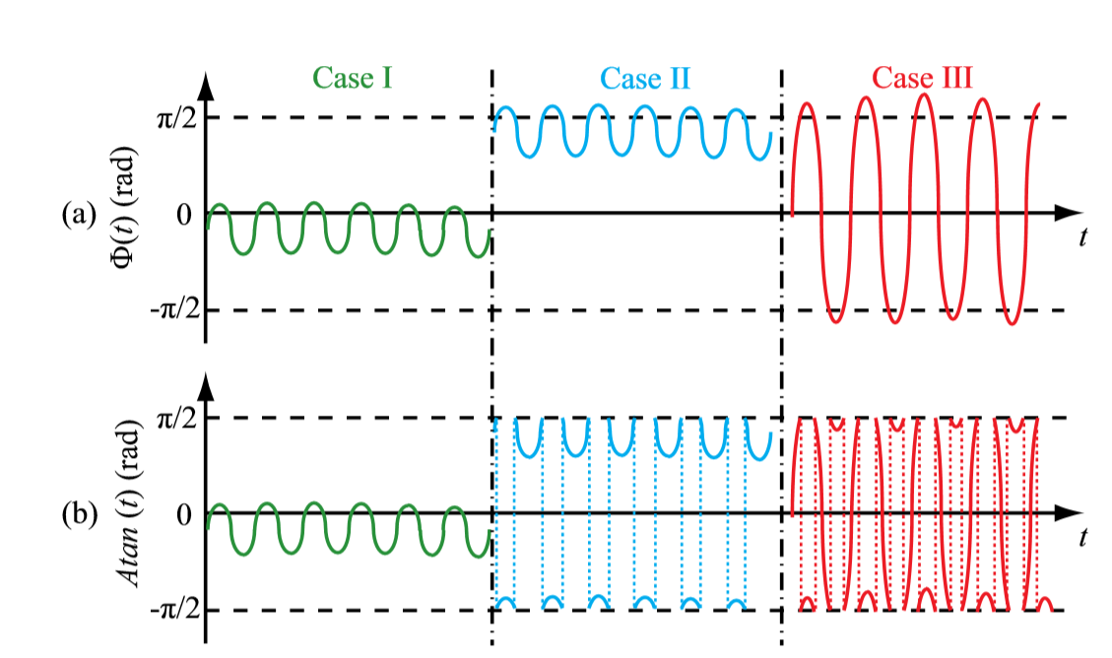

Fig.2 (a) Desired phase demodulation results and (b) the corresponding arctangent demodulation results [1]

Another phase demodulation algorithm is the differentiate and crossmultiply (DACM) algorithm[5, 1中15]. Unlike the arctangent demodulation algorithm, the DACM algorithm obtains the result by the derivation of the arctangent function [5]:

$$\begin{aligned}ω\left(t\right)=\frac{dAtan\left(t\right)}{dt}=\frac{I\left(t\right)\dot{Q}\left(t\right)-\dot{I}\left(t\right)Q\left(t\right)}{I{\left(t\right)}^{2}+Q{\left(t\right)}^{2}}\#\left(2.6\right)\end{aligned}$$

where $\dot{Q}\left(t\right)$ and $\dot{I}\left(t\right)$ means the time derivative of Q(t) and I(t), respectively. $ω\left(t\right)$ is the differential of $Φ\left(t\right)$. Therefore, $Φ\left(t\right)$ can be reconstructed by the integration of $ω\left(t\right)$. In digital domain, the $Φ\left[n\right]$ could be reconstructed by[5]:

$$\begin{aligned}Φ\left[n\right]=\sum_{k=2}^{n}{\frac{I\left[k\right]\left\{Q\left[k\right]- Q\left[k-1\right]\right\}-\left\{I\left[k\right]- I\left[k-1\right]\right\}Q\left[k\right]}{I^{2}\left[k\right]+Q^{2}\left[k\right]}} \#\left(2.7\right)\end{aligned}$$

where the differentiation is approximated by a forward difference, and the integration is replaced with an accumulation. Note that ω(t) is a single-valued function, thereby, the codomain restriction does not exist in this algorithm.

Recently, a modified DACM algorithm is reported[学姐]， which has simplified expression but much improved performance for high-linear motion detection. Different from the traditional DACM algorithm shown in (2.6), the modified DACM algorithm does not include arctangent function. The theory is as follows. The baseband I/Q signal shown in Fig.1 could be modeled as:

$\begin{aligned}I\left(t\right)=\cos\left[\frac{4πΔx\left(t\right)}{λ_{c}}+\frac{4πd_{0}}{λ_{c}}\right]\#\left(2.8\right)\end{aligned}$

$$\begin{aligned}Q\left(t\right)=\sin\left[\frac{4πΔx\left(t\right)}{λ_{c}}+\frac{4πd_{0}}{λ_{c}}\right]\#\left(2.9\right)\end{aligned}$$

First, apply differentiation to equations (2.8) and (2.9):

$\begin{aligned}I^{'}\left(t\right)=-\sin\left[\frac{4πΔx\left(t\right)}{λ_{c}}+\frac{4πd_{0}}{λ_{c}}\right]∙{4π{∆x}^{'}\left(t\right)}/λ\#\left(2.10\right)\end{aligned}$

$\begin{aligned}Q^{'}\left(t\right)=\cos\left[\frac{4πΔx\left(t\right)}{λ_{c}}+\frac{4πd_{0}}{λ_{c}}\right]∙{4π{∆x}^{'}\left(t\right)}/λ\#\left(2.11\right)\end{aligned}$

Second, based on the trigonometric function $\cos^{2}{Φ}+\sin^{2}{Φ}=1$, ${∆x}^{'}\left(t\right)$ can be extracted from (2.10) and (2.11):

$$\begin{aligned}{∆x}^{'}\left(t\right)=\frac{λ}{4π}\left[I\left(t\right)Q^{'}\left(t\right)-I^{'}\left(t\right)Q\left(t\right)\right]\#\left(2.12\right)\end{aligned}$$

As shown above, the differential form of the target motion does not include arctangent function. The motion trajectory $∆x(t)$ can be obtained by apply an integration function to ${∆x}^{'}\left(t\right)$. The complete process of the modified DACM algorithm is shown in Fig.3. In digital domain, the motion trajectory can be obtained by:

$\begin{aligned}x\left[n\right]=\frac{λ}{4π}\sum_{k=2}^{n}{I\left[k-1\right]Q\left[k\right]-I\left[k\right]Q\left[k-1\right]}\#\left(2.13\right)\end{aligned}$

It should be noted that the relationships between $ω\left(t\right)$, $Φ\left[n\right]$ and ${∆x}^{'}\left(t\right)$, $x\left[n\right]$ are ${∆x}^{'}\left(t\right)=ω\left(t\right)λ/4π$ and $x\left[n\right]=Φ\left[n\right]λ/4π$, respectively. Compare (2.7) and (2.13), the proposed algorithm does not include $I^{2}\left[k\right]+Q^{2}\left[k\right]$, which decreases the signal-to-noise ratio requirements of the signal and thereby the improves the accuracy of the demodulation.

2.1.3 Advancements in CW radar

Over the past few decades, researchers over the world have made tremendous efforts to promote Doppler radar research. Various techniques have been proposed on both the signal processing and the hardware to increase the robustness and the accuracy of radar motion detection [6], [7], [18], [19]. On the hardware side, many architectures of CW radar have been explored. A typical example is self-injection-locked (SIL) CW radar. On the signal processing side, many algorithms that can significantly improve the performance of CW radar have been proposed. To deal with the hardware demerits, compensation algorithms based on radar measured data and ellipse ﬁtting were proposed to eliminate the impact of I/Q imbalance [23-24]. To deal with ac coupling in low-complexity Doppler radar, a digital post-distortion (DPoD) technique is proposed to compensate for the signal distortions in the digital baseband domain.

All the advancements have given CW radar great application prospects. One typical example is contactless vital sign monitoring.

2.2 Vital signs monitoring via CW radar

2.2.1 Cardiopulmonary monitoring

As early as in 1975, CW radar has been used in respiration monitoring by Professor James C. Lin [CLI, 9]. Since then, the application of CW radar in cardiopulmonary monitoring has drew much attention[CLI 里面找心肺图的参考文献].

Figure 3 shows an experimental setup of an instrument based CW radar for cardiopulmonary monitoring []. The instrument based CW radar system includes Agilent spectrum analyzer E4407B, Agilent vector signal generator E8267C, and Agilent vector signal analyzer 89600S. E8267C is utilized as a local oscillator (LO) to generate stable RF signal. E4407B is utilized as a mixer to convert the motion modulated RF signal to IF signal. 89600S is utilized as an analog-digital converter (ADC) and signal processer. The subject person sits around 1m from the radar and breaths normally. A pulse sensor (HK-2000B) is wrapped around the wrist of the subject person to detect his heartbeat signal. The signal is digitized by TDS7104 and used as a reference signal to the heartbeat signal detected by the CW radar. A 2.4-GHz printed patch antenna is used to validate the cardiopulmonary monitoring performance of the system, which means the radar system works at 2.4 GHz.

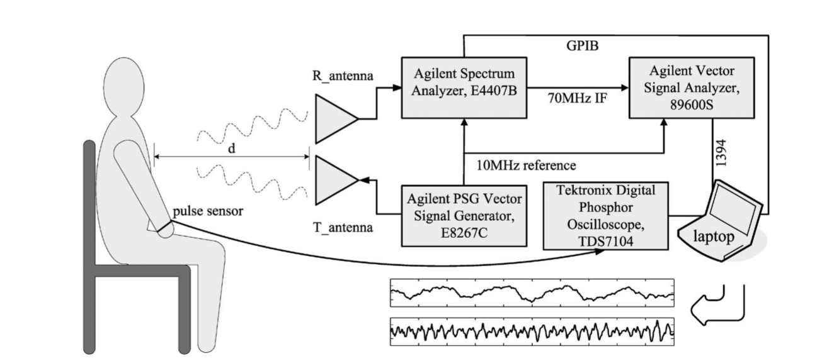

Fig.3 Experimental setup of an instrument based CW radar []

The captured respiration and heartbeat curve of the experiment are shown in Fig.4 and Fig. 5 respectively. The upper curve in Fig.4 is the baseband output signal, which is also known as raw data. The lower curve in Fig. 4 is the filtered respiration signal. The filtered respiration signal is the same as the raw data in periodicity but becomes smoother after filtered. The upper curve of Fig. 5 represents the filtered beat signal and the lower curve represents the reference heartbeat signal detected by the pulse sensor HK-2000B. As shown, the heartbeat cycles of the two curves in Fig.5 match 100 percent, indicating that under this experimental condition, the heartbeat detection accuracy of the CW radar system is the same as that of HK-2000B.

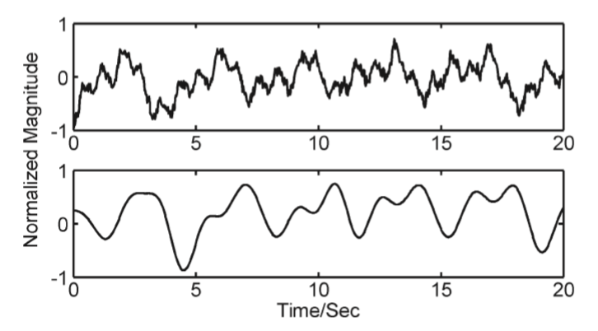

Fig.4 Detection results. The upper trace represents the baseband output recorded by VSA software. The lower trace represents the ﬁltered respiration signal.

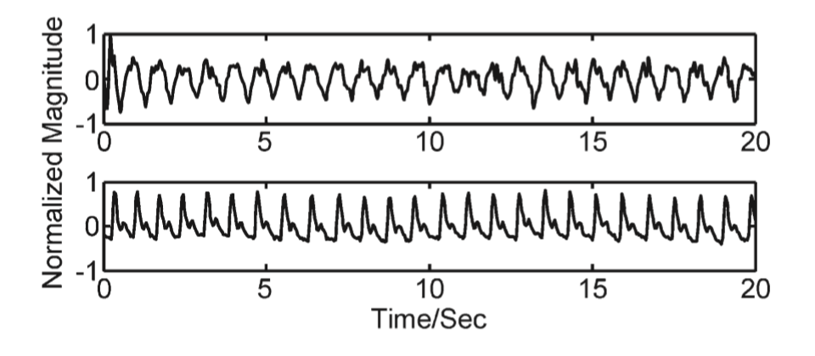

Fig.5 Detection results. The upper trace represents the ﬁltered heartbeat signal. The lower trace represents the reference signal.

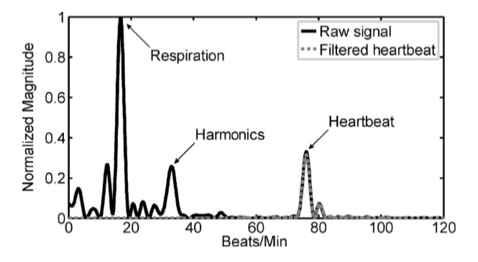

Fig.6 Frequency spectrum of the raw signal and ﬁltered heartbeat signal. The breathing rate is about 17 beats/min, and the heartbeat rate is about 78 beats/min.

In addition to the time-domain form of the signal, the frequency-domain form of the signal can more intuitively express the information of respiratory rate and heart rate. By performing FFT on the data used in Fig.4 and Fig.5, the frequency-domain spectra of the signals are obtained and shown in Fig. 6. The solid line is obtained by the raw data and the dashed line is obtained by the filtered heartbeat data. The abscissa is converted from Hz to beat/min, indicating the number of breaths or heartbeats in one minute. The signal amplitude is normalized. As shown, it is easy to identify the harmonics of the respiration signal and the heartbeat signal, and the breath rate and heartbeat rate can be easily obtained by finding the peak values of the spectra. In this case, the heartbeat is around 17 beats/min and the breath rate is around 78beats/min.

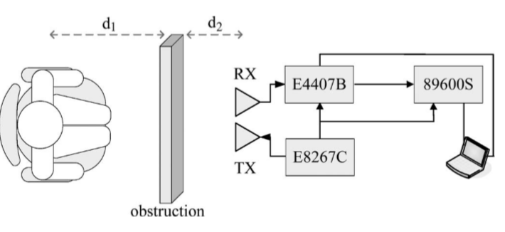

Fig.7 Measurement setup with obstructions

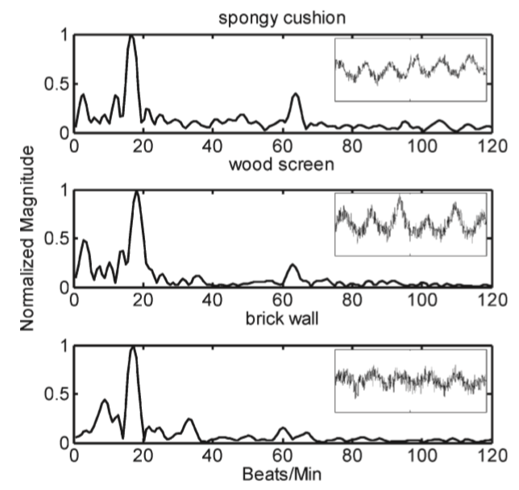

Fig.8 Measured baseband spectra with three types of obstructions (spongy cushion, wood screen, and brick wall). The insets indicate the corresponding raw time-domain signals.

Microwaves are penetrating. Therefore, CW radar can penetrate obstacles for cardiopulmonary monitoring. The experiment shown in Fig. 7 is taken as an example to reveal the penetration ability of the CW radar [xx]. The radar system used in Fig.7 is the same CW radar system shown in Fig.3. As shown, the subject person faces obstructions from a distance of $d_{1}$ away and the obstruction is $d_{2}$ away from the radar. The obstructions include a spongy cushion (19 cm thick), a wood screen (3.7 cm thick), and a brick wall (30 cm thick). The measured results are shown in Fig. 8. As shown, Radar can still accurately perform cardiopulmonary monitoring with three different obstacles in between, which means the radar system has good performance in penetrating obstructions. The insets of Fig.8 are the raw signals.

There are also many other CW radar systems designed for cardiopulmonary monitoring[xx-xx]. Fig.9 shows a compact CW radar system for cardiopulmonary monitoring. As shown, the radar system is smaller than a palm and can send the sampled baseband data to PC remotely by Bluetooth. With the development of the integrated circuit, the radar system can be made even more smaller and has wide commercial application prospects.

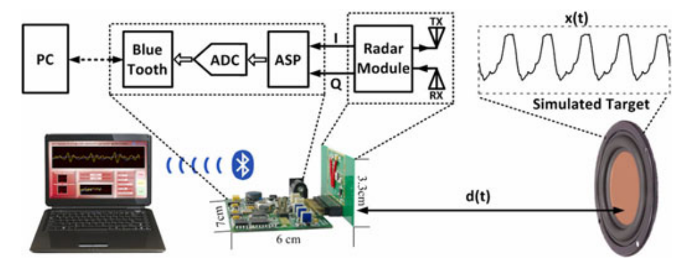

Fig.9 Schematic of radar sensor system and the experiment setup.

2.2.2 Human gait recognition

As early as in 2005, the application of CW radar in human gait recognition had been explored []. Afterwards, CW radar based human gait recognition has been deeply researched.

Figure 10 shows an example of CW radar system utilized for human gait recognition [步态]. The system is compact, low cost and low power. The size of the system is only $1.75 inches ×1.5 inches$. The output power is about 10 mW. It operates at around 10.525 GHz. A dielectric resonant oscillator (DRO) is used as the LO.

The process of walking is a complex movement process. When a person is approaching or leaving the CW radar, the signals reflected from the various components of the body will have a Doppler shift that is proportional to the velocity of those components. The primary components of the reflected signal are from the torso, legs, and arms. Consider the simplest case. Suppose a person moves in a straight line at a constant speed $v_{0}$. As shown in Fig.11, the signal reflected from the torso, $s_{0}(t)$, will have a constant Doppler shift. The signals reflected from the swinging legs and arms, $s_{m}(t)$, will be modulated at the cadence frequency, $f_{m}$, which is the step or leg swing rate. In general, the arms and legs will have the same periodicity since the arms swing to counterbalance the legs [].

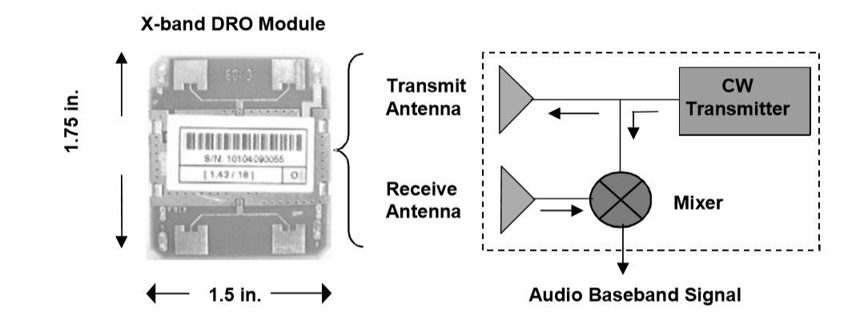

Fig.10 CW Radar Module.

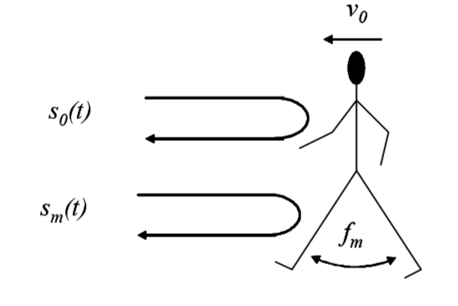

Fig.11 Key signal components from a walking person.

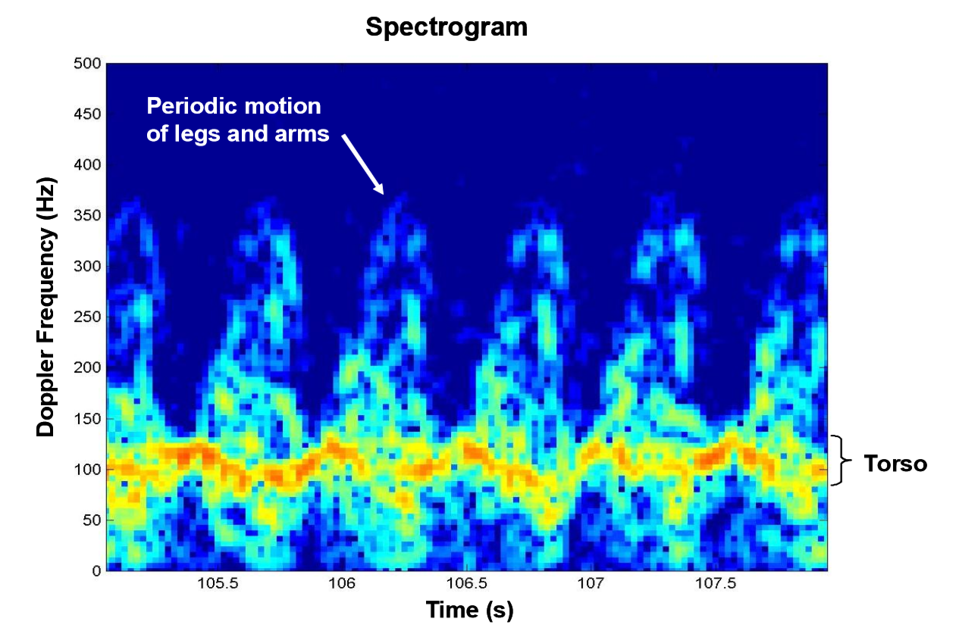

Fig. 12 Spectrogram of a person walking.

To extract the velocity components of the target from the radar’s signal, a short-time Fast Fourier Transform (FFT) was used to form spectrograms, also called Doppler signature. Fig.12 shows a typical Doppler signature of a person walking. The plots are obtained by taking a succession of FFTs, each over a short time window of 0.1 seconds. the time spacing between FFT windows is 0.025 seconds. The Doppler frequency is displayed on the vertical axis and time on the horizontal. On the time axis, every second is divided into 8 Doppler spectra. The amplitude of the reflected signals is color coded with red being the highest intensity and blue the lowest. By taking short-time FFTs, the velocity and amplitude of the moving body components of the subject person are separated. In Fig. 12, a nearly constant Doppler frequency of about 100 Hz caused by the torso movement indicates that the person was moving with a constant speed. By utilizing equation (2.4), the constant speed is about 1.4 $m/s$. The nearly sawtooth modulation on top of this torso component is introduced by the leg swings. As shown, 6 leg swings in the 3 seconds of data indicates that the cadence frequency is about 2 Hz. The contribution of the arms to the Doppler signature is not as dominant in this case.

One application of analysis of radar Doppler signatures is discriminating humans from animals. This could be very useful for sensor applications in remote areas, such as border surveillance between two countries, where false alarms from animals could be a significant problem. A comparison of the Doppler signatures of a human and a dog is shown in Figure 13. The difference in the modulation pattern due to the leg motion between the two is very noticeable. The shorter, thinner legs of the dog have a narrower and sharper Doppler pattern compared to the broader, saw-tooth pattern for the human. The regular motion of the two legs for the human is very discernable whereas it is more complex for the four-legged dog. There may also be a Doppler component due to the wagging tail of the dog. With the development of artificial intelligence (AI), CW radar will not only distinguish between humans and animals, but may also identify specific animals, such as cattle and sheep, and detect whether they are injured. A database of animal signatures would first need to be acquired to achieve this.

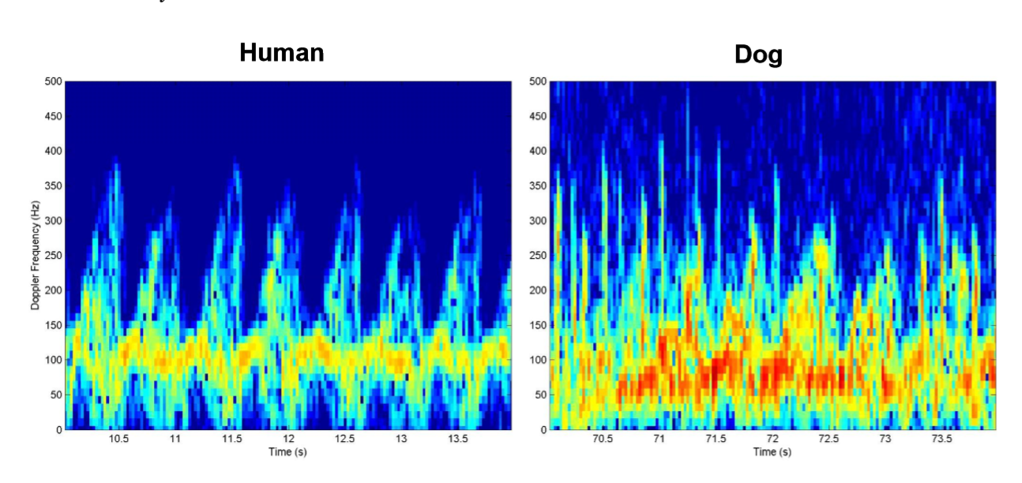

Fig. 13 Human and dog Doppler signatures.

Besides the Doppler signatures, useful biomechanical information can also be extracted through further analysis of the collected signals. A simpler approach is introduced as follows.

Since the motion of the legs and arms of a walking person is periodic, it was natural to use the Fourier transform to extract basic information such as the cadence frequency from the spectral image shown in Fig. 12. For each Doppler bin on the vertical axis in this figure an FFT was applied over the entire time frame. The length of the time window is chosen to provide enough gait cycles to resolve the cadence frequency for a typical walking subject. The result is that the vertical scale is preserved and the horizontal time axis is transformed to the frequency domain as shown in Fig. 14. This image allows for a unique, three-dimensional display of the spectral decomposition of the human gait. The frequency and harmonic content of the individual moving body components are displayed on the horizontal or x-axis, their corresponding velocities on the vertical or y-axis, and their radar cross-section (RCS) on the intensity scale or z-axis. Since the torso is moving with a fairly constant velocity and with little or no modulation, its signal component is the peak that lies near zero on the cadence frequency axis and is offset in Doppler, about 100 Hz, by its velocity (highlighted in Fig.14). From this we obtain the velocity, v0, and

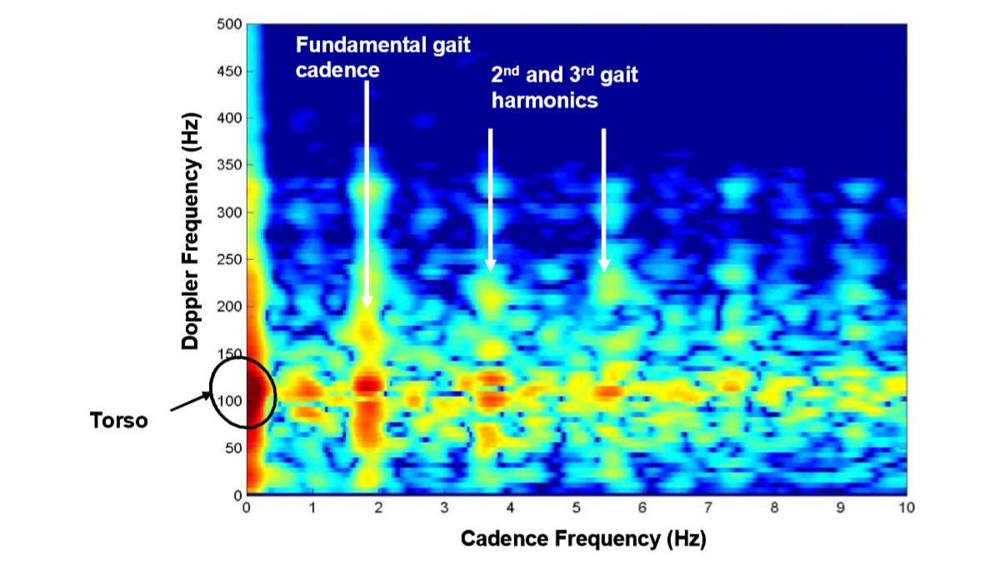

Fig. 14 Spectral analysis of Fig.12

the amplitude of the RCS of the torso. The modulation of the legs has a fundamental cadence frequency, $f_{m}$, of about 1.8 Hz.

Then the stride can be extracted by dividing the velocity by the cadence frequency:

$$\begin{aligned}stride=\frac{v_{0}}{f_{m}}\#\left(2.14\right)\end{aligned}$$

which was chosen as the second feature. In the example of Fig. 12, the stride is 0.89 meters. A third feature was chosen that related the ratio of the RCS of the moving appendages (arms and legs) to the torso. It is assumed that this feature can also help in discriminating humans from animals, since the ratio of the area of the appendages to the torso is probably unique to each animal. Another advantage of using the spectral decomposition of Fig. 14 is that it separates the reflections from the appendages, which move in a periodic manner, from that of the torso. The RCS of the appendages is determined by summing the amplitudes of the peaks of the fundamental and the sencond and third harmonics that are associated with the periodic motion of the arms and legs. This is then divided by the amplitude of the torso peak in the spectrum. This feature is referred to as the appendage/ torso ratio.

$$\begin{aligned}\frac{appendage}{torso}=\frac{\sum_{n=1}^{3}{RCS_{n}}}{RCS_{0}}\#\left(2.15\right)\end{aligned}$$

where $RCS_{n}$ is the amplitude of the *n-th* peak: $n = 0$ being the torso, and $n = 1, 2$ and 3 the fundamental, second, and third gait harmonics, respectively. Based on (2.14) and (2.15), a multi-class classifier that can discriminate humans from animals can be built. It is further discussed in [xx].

2.2.3 Cancer medical application

Cancer is an important chronic disease that has always troubled people.Radiation therapy is a major modality for treating cancer patients. Studies have shown that an increased radiation dose to the tumor will lead to improved local control and survival rates. However, in many anatomic sites (e.g., lung and liver), the tumors can move signiﬁcantly (∼2–3cm) with respiration. The respiratory tumor motion has been a major challenge in radio therapy to deliver sufﬁcient radiation dose without causing secondary cancer or severe radiation damage to the surrounding healthy tissue [1], [2][xx].

Motion-adaptive radiotherapy explicitly accounts for and tackles the issue of tumor motion during radiation dose delivery, in which respiratory gating and tumor tracking are two promising approaches[xx]. Both of the two approached need accurately measured respiration pattern to either generate gating signals or derive the real-time tumor locations[xx].

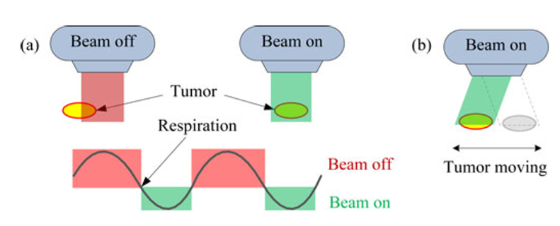

Fig.15 Mechanism of (a) respiratory-gated radiotherapy and (b) tumor tracking.

In respiratory gated radiotherapy, the mechanism of which is shown in Fig. 15 (a), the radiation dose is delivered to the tumor only when it moves into the radiation coverage.When the tumor moves out of the radiation coverage, the radiation is turned off. Gating of th eradiation beam can be based on either amplitude or phase of the respiration signal. Duty cycle and residual motion are two important parameters that characterize a gated treatment. Duty cycle is the percentage of time that radiation is turned on during a breathing cycle.Residual motion is the amount of tumor motion during radiation beam on. In respiratory gating, there is a trade off between duty cycle and residual motion. Longer duty cycle means longer radiation exposure to the tumor and shorter overall treatment time, but it also means larger residual motion of the tumor, which will expose more healthy tissues to the radiation. The duty cycle is determined by the doctor at the treatment preparation stage, according to speciﬁc patients and different treatment strategies.

The CW radar has the potential application of real-time tumor tracking for motion-adaptive radiotherapy [3]. Respiratory gating has to leverage the trade off between duty cycle and residual tumor motion. However, this demerit is eliminated in the tumor tracking type of treatment,in which,the radiation beam is always on and dynamically follows the moving tumor in real time, as shown in Fig. 15 (b). Fig.16 shows a real Motion-adaptive radiotherapy system based on radar respiration sensing.

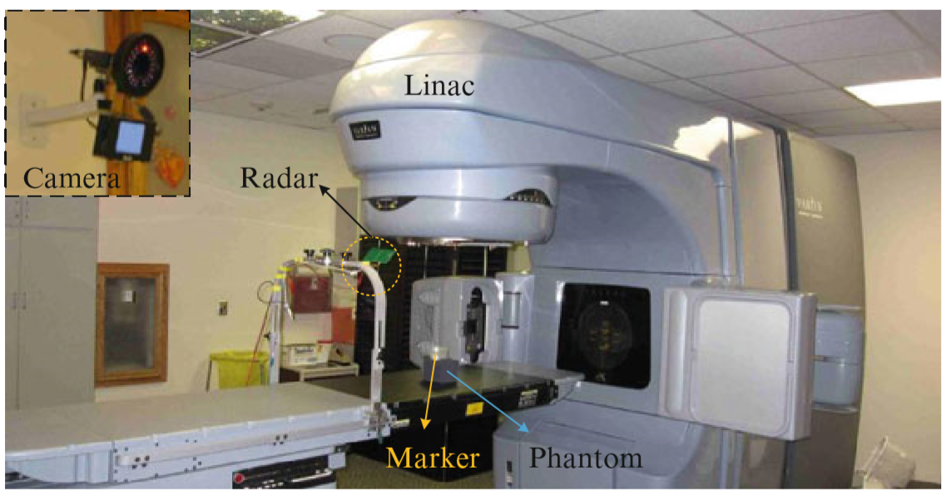

Fig.16 a real Motion-adaptive radiotherapy system based on radar respiration sensing.

1. Vital sign monitoring through FMCW radar

3.1 Composition of FMCW radar system

The composition of FMCW radar system mainly includes: sawtooth wave signal generator, transceiver module, digital-to-analog converter, digital signal processor and controller. The signal is generated by the sawtooth wave signal generator, passed through the frequency multiplier and the power amplifier in turn, and transmitted by the transmitting antenna. The electromagnetic wave is reflected by the object and received by the receiving antenna. The received signal is mixed with the transmitted signal after passing through a low-noise amplifier to obtain an intermediate frequency signal. Finally, the intermediate frequency signal is filtered and ADC sampled sequentially, and then input to the back end for further signal processing. The block diagram of a typical FMCW radar system is shown in Figure 2.1.

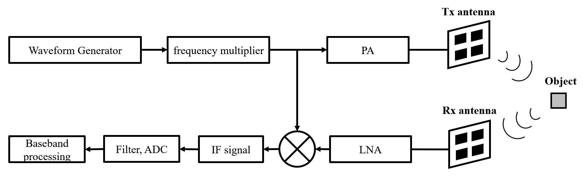

Fig. 2.1. Block diagram of a typical FMCW radar system

* 1. Analysis of FMCW Radar IF Signal

For FMCW radar, a variety of modulations is possible. The transmitter frequency can slew up and down as follows: Sine wave, Sawtooth wave, Triangle wave, Square wave, etc.

Sawtooth modulation is the most used in FMCW radars, so the following analysis is based on the sawtooth wave.

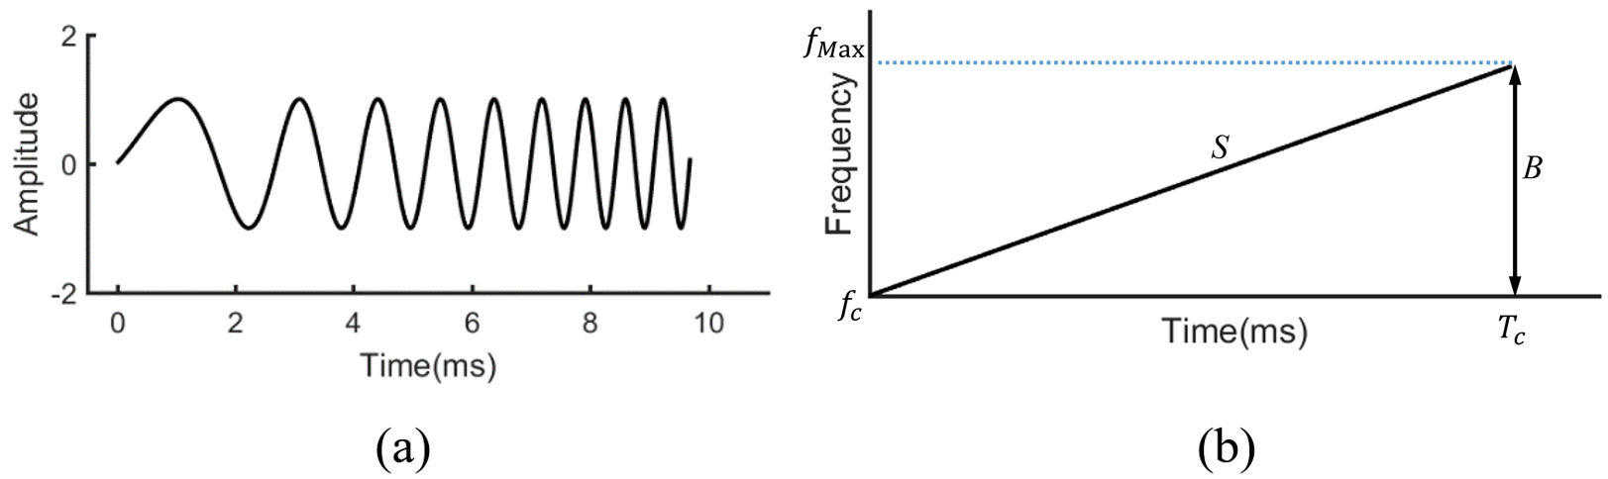

Fig. 2.2. Block diagram of a typical FMCW radar system

The sawtooth wave of FMCW radar is a frequency linear modulation method. The frequency of electromagnetic waves changes linearly with time. The schematic diagram is shown in Figure 2.2. Figure 2.2 (a) shows the time domain representation. The transmitted signal in a cycle is usually called a chirp. Figure 2.2 (b) shows the frequency-time diagram of a chirp.

Denote $T_{c}$ as the chirp repetition period, $B$ is the bandwidth of the chirp, $S=B/T_{c} is the slope of the frequency modulation$. The mathematical expression for the transmitted signal within one frequency ramp interval is:

|  |  |  |
| --- | --- | --- |
|  | $$s_{Tx}\left(t\right)=exp⁡(j(2πf_{c}t+πSt^{2}+ϕ))$$ |  |

where $f_{c}$ is the center frequency of the frequency ramp, $ϕ$ is the initial phase residual, $t∈[-T_{c}/2, T_{c}/2]$. Suppose that there is a reflection point, and its distance from the radar as a function of time is $R(τ)$. Assuming that the movement of the scattering point is relatively slow, thus $R(τ)$ can be regarded as a constant within a certain period. This is a "stop-and-go" hypothesis, which is extremely common when dealing with slow moving targets. Therefore, for the scattering point located at $R(τ)$, the echo signal received by the FMCW radar is a function of the time delay $Δt$ and a certain amplitude attenuation $σ$ of the transmitted signal. Among them, the time delay is:

|  |  |  |
| --- | --- | --- |
|  | $$Δt=\frac{2R(τ)}{c}$$ |  |

Therefore, the echo signal can be expressed as:

$$s_{Rx}\left(t\right)=σs_{Tx}\left(t-Δt\right)$$

$=σ·\exp\left(j\left(2πf_{c}\left(t-Δt\right)+πS{\left(t-Δt\right)}^{2}+ϕ\right)\right)$

According to Figure 2-1, the received signal is mixed with the transmitted signal. After that, the resulting mixed signal is low-pass filtered and the intermediate frequency signal is obtained:

$$s_{IF}\left(t\right)=f_{LPF}\left\{s_{Tx}\left(t\right)·s_{Rx}\left(t\right)\right\}$$

|  |  |  |
| --- | --- | --- |
|  | $$=σ·\exp\left(j\left(\frac{4πSR(τ)t}{c}+\frac{4πf_{c}R(τ)}{c}-\frac{4πSR^{2}(τ)}{c^{2}}\right)\right)$$ |  |

It can be seen from equation (2-4) that the obtained intermediate frequency signal is a sinusoidal motion with frequency :

|  |  |  |
| --- | --- | --- |
|  |  |  |

* 1. FMCW radar parameter estimation

Based on the intermediate frequency signal obtained in Section 2.2, parameters such as the position, velocity, and angle of the target object can be estimated. The parameter estimation methods are discussed separately below.

3.3.1 FMCW radar range estimation

Since the frequency of the EM wave emitted by the FMCW radar system changes linearly with time, the frequency of the received EM wave also changes linearly with time. Therefore, when the frequency of the IF signal obtained by mixing the transceiver signals is determined, the distance of the object can be obtained according to the known slope S of the sawtooth wave modulation.

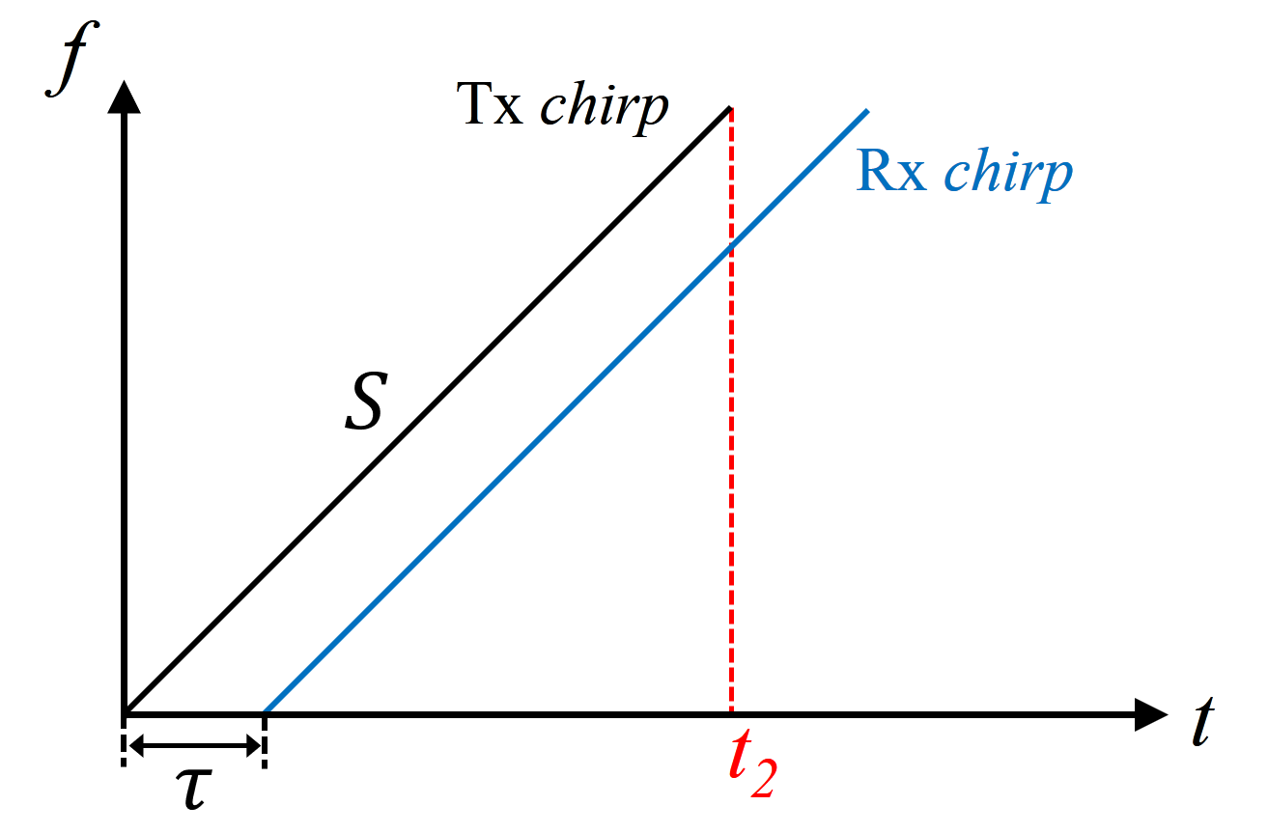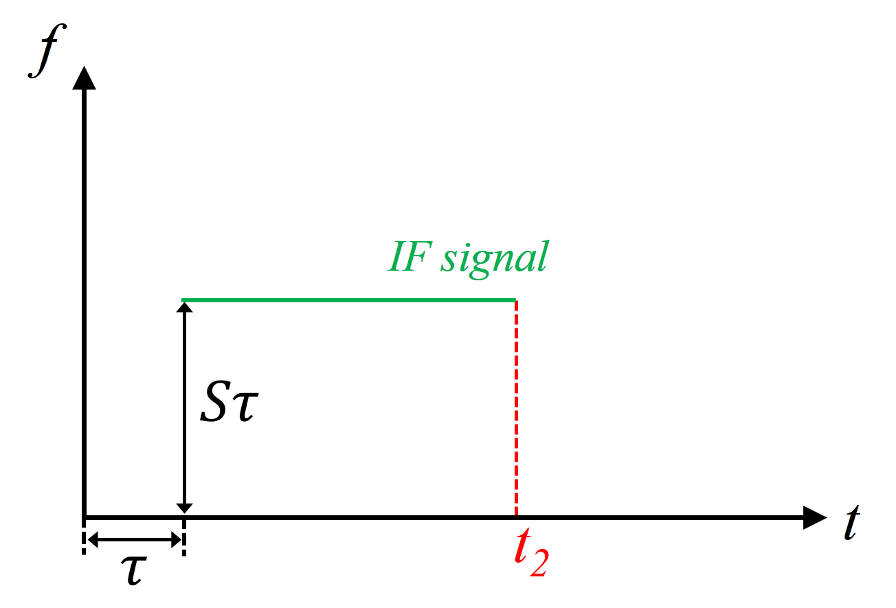

(a) (b)

Fig. 2.3. FMCW intermediate frequency signal diagram

As shown in Figure 2.3, the transmitted signal is received by the radar after time $τ$. Therefore, the transmitted Tx chirp and the received Rx chirp are two parallel lines with the same slope on the frequency-time graph. Note that the slope of the transmitted sawtooth wave is S, and the duration of the transmitted signal is $t_{2}$. The frequency-time diagram of the IF signal is shown in Figure 2.3 (b). The frequency of the intermediate frequency signal $f_{IF}=Sτ$.

Therefore, when there is a single object in front of the radar, the frequency-time diagram of the generated intermediate frequency signal is a single-valued line, and the frequency is proportional to the EM wave propagation time. From formula (2-2), we know that the propagation time is proportional to the distance from the object to the radar, that is $τ=2d/c$, where *d* is the distance from the object to the radar.

In summary, the distance from the object to the radar can be obtained from the frequency $f_{IF}$ of the intermediate frequency signal obtained in equation (2-4):

|  |  |  |
| --- | --- | --- |
|  | $$d=\frac{cf_{IF}}{2S}$$ |  |

It should be noted that when using ADC for sampling, the time-point of interest must be within the time window of [$τ$, $t_{2}$].

3.3.2 FMCW radar velocity estimation

The FMCW radar speed estimation requires the use of multiple periods of Tx chirp. By extracting the changes of the phase information of multiple chirps, the displacement of the object within the two sawtooth wave periods is obtained, and then the estimation of the object's velocity is completed.

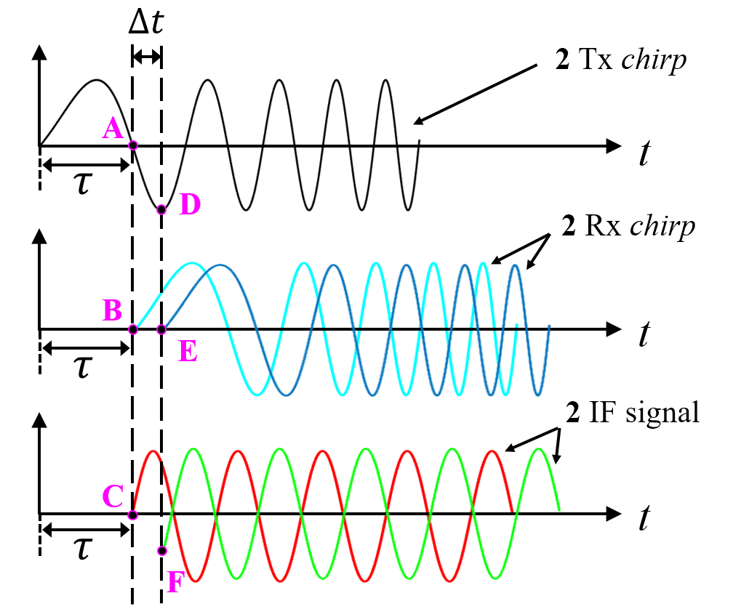

Fig. 2.4. Phase analysis of FMCW radar IF signal

The first step is the phase analysis of the FMCW radar IF signal. The top graph in Figure 2.4 is the time-domain waveform of the transmitted signal. Assuming that two chirps are continuously transmitted, the repetitive time of the transmitted signal waveform is $T_{c}$. Since the repetitive time $T_{c}$ is generally in the μs level, which is very small relative to the time axis, the image of the two consecutive transmitted signal waveforms on the time axis can be considered overlapping. That is, the top image is actually a superimposed image of two transmitted waveforms with very short intervals on the time axis.

Suppose the first Tx chirp emitted returns after time τ, forming the light blue waveform in the middle image in Figure 2.4, and the second Tx chirp returns after time $(τ+∆t)$ as a dark blue waveform. The $∆t$ delay is caused by a slight displacement of the object within two repetitive periods of emitted Tx signal waves. It should be noted that $τ$ and $∆t$ are also very small amounts of time, so they are enlarged for display here.

The bottom figure of Figure 2.4 is the IF signal formed by the two received signals and the transmitted signal respectively. By analyzing the phases of the two IF signals, the moving distance $∆d$ of the object during time $T_{c}$ can be obtained.

It can be obtained from Figure 2.4 that the phase difference between point A and point D is $∆Φ=2πf_{c}Δt=4πΔd/λ$. At the same time, we get the relationship in the waveform: point B and point E are 0 phase, the phase of point C is the negative value of phase A; the phase of point F is the negative value of phase D. Therefore, the phase difference $∆Φ$ between point A and point D is also the phase difference between point C and point F.

According to the conclusion in section 2.2, the expression of sinusoidal IF signal can be rewritten as follows:

$S_{IF}\left(t\right)=Asin(2πft+Φ)$

where $f=S∙2d/c$ is the frequency of the signal, c is the speed of light.

When there are two IF signals, the phase difference $∆Φ$ is:

$∆Φ=4πΔd/λ$

note $ω=∆Φ=4πvTc/λ$, then the velocity estimation is:

$v=λω/4πT_{c}$

Taking the example that have mentioned before. For a FMCW radar operating at 77 GHz, the phase change $∆Φ=4πΔd/λ=180°$. It can be concluded that the frequency is almost negligible for small movement changes, but the phase information is very sensitive to small distance changes. Therefore, the phase information is used to complete the velocity estimation with higher resolution.

It should be noted that because the speed is detected using changes in phase information, it must be effective within the range of $|ω|<π$, which limits the maximum upper limit of speed estimation $v_{Max}$:

|  |  |  |
| --- | --- | --- |
|  | $$v_{Max}<\frac{λ}{4T_{c}}$$ |  |

In addition, the direction of the object's movement relative to the radar can be distinguished by the sign of $ω$:

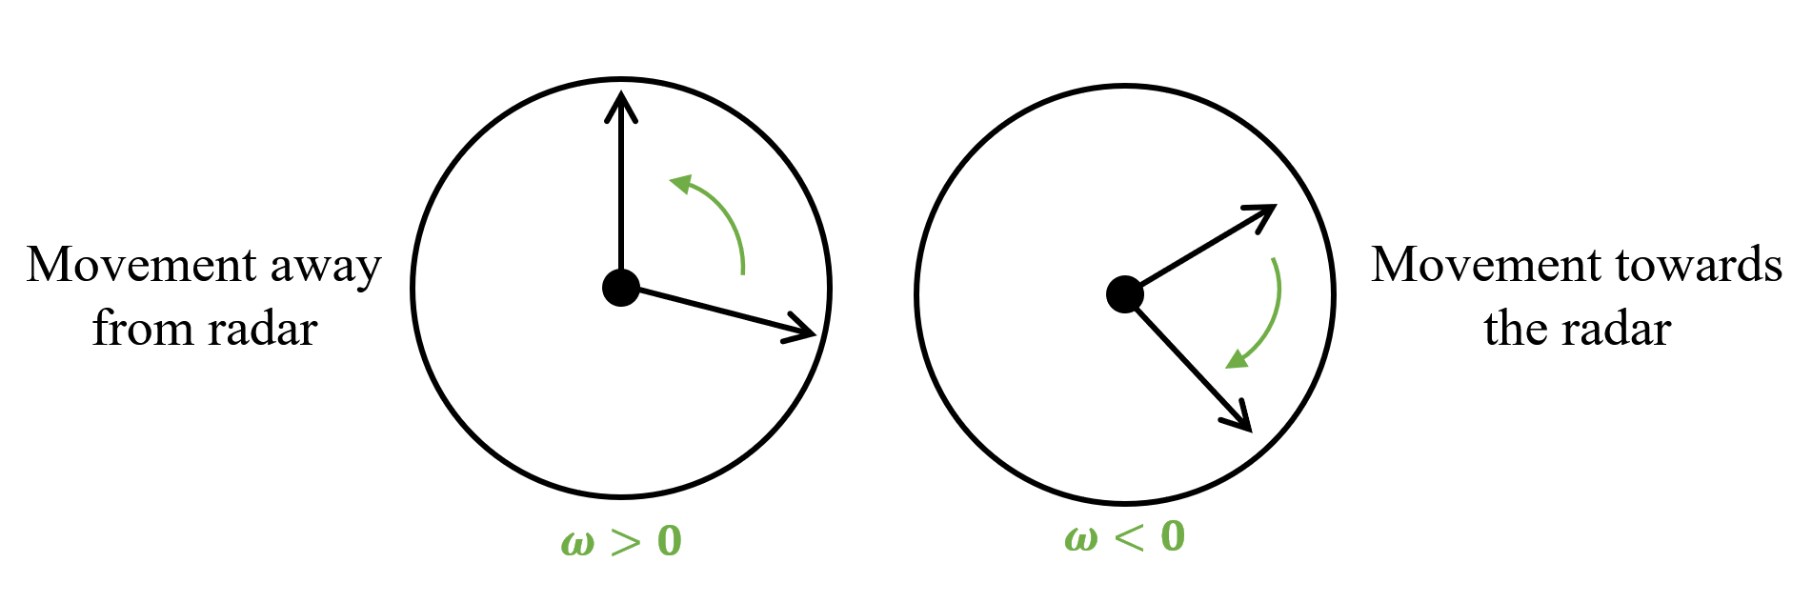

Fig. 2.5. Relationship between phase sign and object movement direction

As shown in Figure 2.5, when $ω>0$, the object moves in the direction away from the radar. When $ω<0$, the object moves in the direction of approaching the radar.

3.3.3 FMCW radar angle estimation

The angle estimation of the FMCW radar requires at least two receiving antennas. The schematic diagram is shown in Figure 2.6.

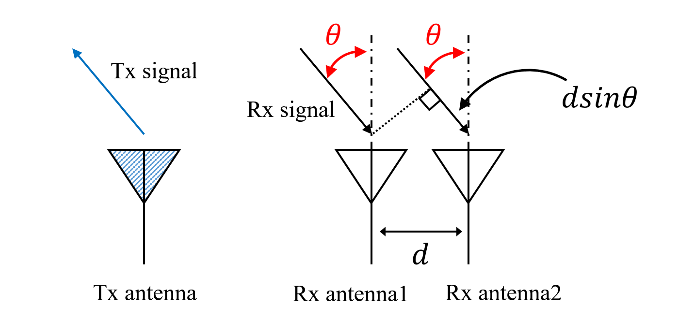

Fig. 2.6. Schematic diagram of FMCW radar angle estimation

Assuming that the distance between the two receiving antennas is *d*, since *d* is relatively small compared to the distance from the object to the radar, the reflected signals reaching the two receiving antennas can be regarded as parallel incidence. Assuming the normal angle between the object and the receiving antenna is $θ$, the reflected signals received by the receiving antennas 1 and 2 have a wave path difference $∆d=dsinθ$. Therefore, the phase difference of the reflected signals received by the two receiving antennas contains the angle information of the target.

The phase difference $ω$ between Rx antennas can be expressed as:

|  |  |  |
| --- | --- | --- |
|  | $$ω=\frac{2π∆d}{λ}=\frac{2πdsinθ}{λ}$$ |  |

Inversely transform equation (2-13) to obtain the angle information of the target:

|  |  |  |
| --- | --- | --- |
|  | $$θ=\sin^{-1}(\frac{λω}{2πd})$$ |  |

It should be noted that for equation (2-14), this is the first time that nonlinearity occurs in FMCW radar parameter estimation. The non-linearity of the arc sine function makes the sensitivity differs at different angles.

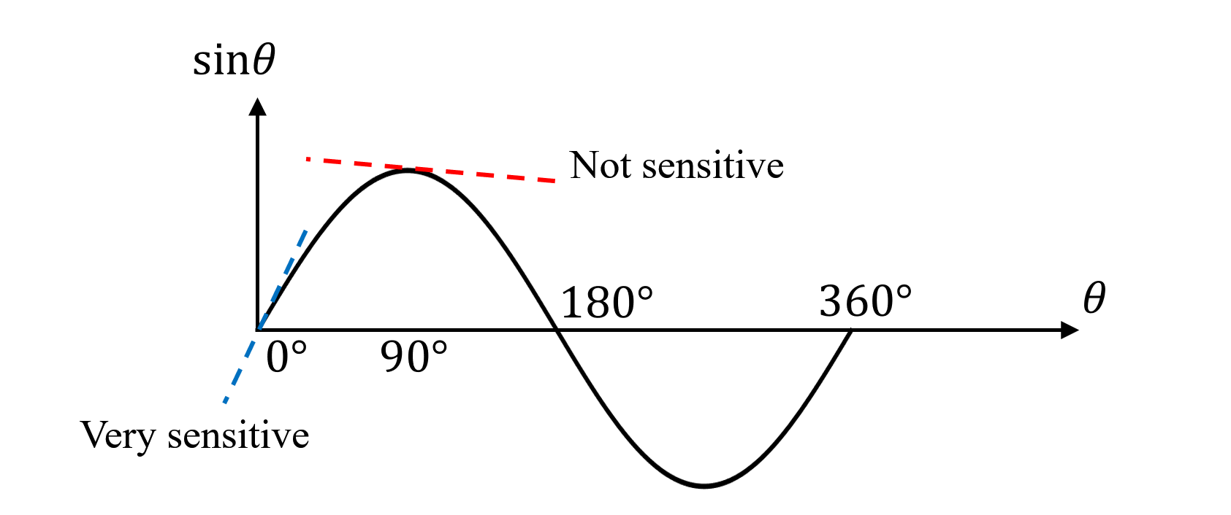

Fig. 2.7. FMCW radar angle estimation sensitivity with angle

As shown in Figure 2.7, when the angle close to 0°, since the slope of the sine function is large, the change of the arc sine function to the angle is obvious, but when it reaches 90°, the slope of the sine function gradually approaches 0, therefore, the accuracy of angle estimation decreases rapidly. That is, when the object is directly in front of the radar, the angle estimation is the most accurate. The closer the target is to the sides of the radar, the worse the angle estimation accuracy will be.

3.3.4 FMCW radar phase-based range-tracking algorithm for vital sign monitoring

Since the displacement of vital signs such as respiration and heartbeat is very small, the phase-based range-tracking algorithm has a better effect on obtaining accurate vital sign detection. If a Fourier transform is performed over each period of the IF signal (2-4), its associated range profile is derived. The IF signal after Fourier transform can be expressed as:

|  |  |  |
| --- | --- | --- |
|  | $$s_{IF}\left(f\right)=σ·T_{c}·\exp\left(j\frac{4πf_{c}R\left(τ\right)}{c}\right)sinc\left(T_{c}(f-\frac{2SR\left(τ\right)}{c}\right)$$ | (2-34) |

where $sinc\left(x\right)=\sin\left(πx\right)/(πx)$. After a simple scaling process of the frequency axis, the corresponding range profile can be extracted.

For an LFMCW radar intended to monitor vital signs, a close look must be given at the exponential factor in (2-34). Denote the phase history in (2-34) as $ϕ_{d}$, then the phase history $ϕ_{d}$ is simply related to the range evolution of the target $R\left(τ\right)$ by

|  |  |  |
| --- | --- | --- |
|  | $$ϕ_{d}=\frac{4πf_{c}R\left(τ\right)}{c}$$ | (2-35) |

Hence, a proper range tracking of the target requires the preservation of the phase history. Assume that the signal samples associated with distinct chirp intervals are stacked in rows. This constitutes the raw-data matrix, which is denominated $M[n, m]$ (*n=1, 2, …, N; m=1, 2, …, M*, *N* being the number of transmitted ramps and *M* being the number of samples per chirp). The corresponding signal processing to derive the range evolution $R\left(τ\right)$ is divided into four steps:

Step 1) Perform a fast Fourier transform over each row of the raw-data matrix M[*n, m*]. Denote the resulting range-profile matrix as R[*n, m*]

Step 2) Choose the range bin *m\** in which the target is found. Synthesize the signal s[*n*]=R[*n, m\**], which is a column of the range-profile matrix R[*n, m*].

Step 3) Exact the phase of the signal s[n] and unwarp it. Denote the phase of the signal s[*n*] as $ψ[n]$.

Step 4) From (2-35), calculate the range estimation as .

* 1. Examples of FMCW radar on contactless vital sign monitoring

s In recent years, FMCW radar has been widely used in noncontact range tracking of vital signs, e.g., respiration. Next, some examples are given to analyze several typical FMCW radars for vital sign monitoring.

3.4.1 Respiration monitoring

The body surface movements due to physiological motions modulates the phase of the received radar signal and can be further processed to extract the breathing and heart-rate. A deramping-based LFMCW radar scheme has been proposed [1]. The described LFMCW radar architecture is conceptually simple and the deramping process greatly simplifies its hardware implementation mainly in terms of sampling speed for the Rx ADC.

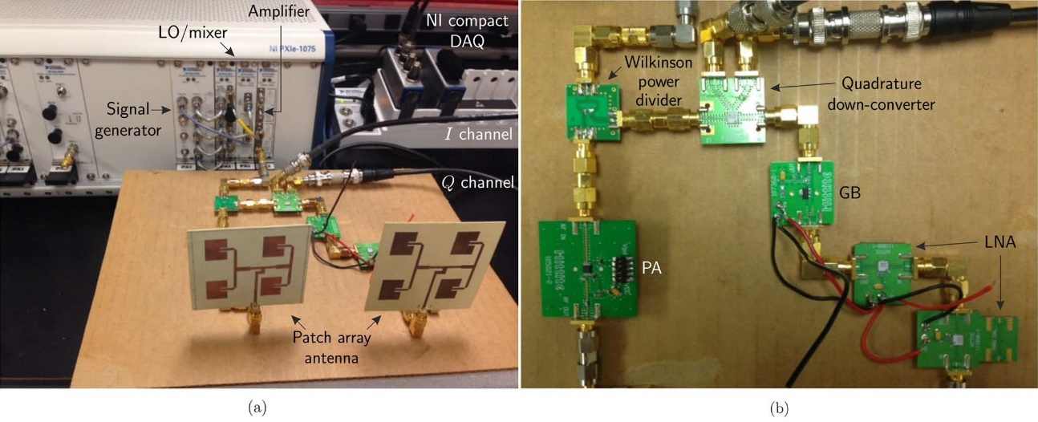

Fig. 2.8. Photograph of the developed LFMCW radar system prototype. (a) Complete view. (b) Detail. [1]

The photograph of the constructed LFMCW radar system is depicted in Fig. 2.8. It consists of Tx, Rx, and signal-acquisition modules. A photograph of the experiment setup for vital-sign sensing from human target is depicted in Fig.2.9.

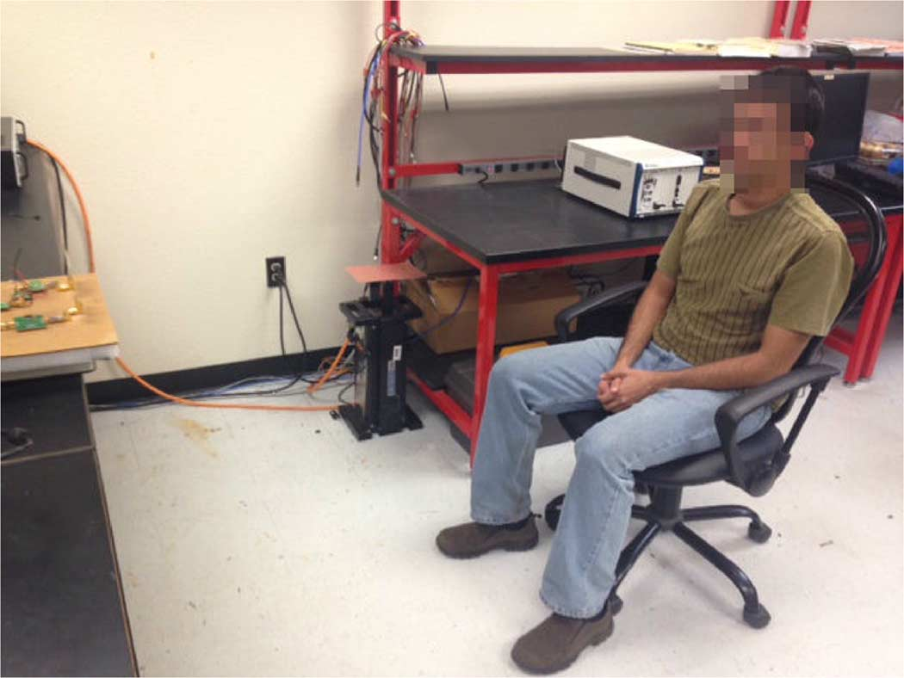

Fig. 2.9. Photograph of the real experimental setup of the human vital-sign

tracking test [1]

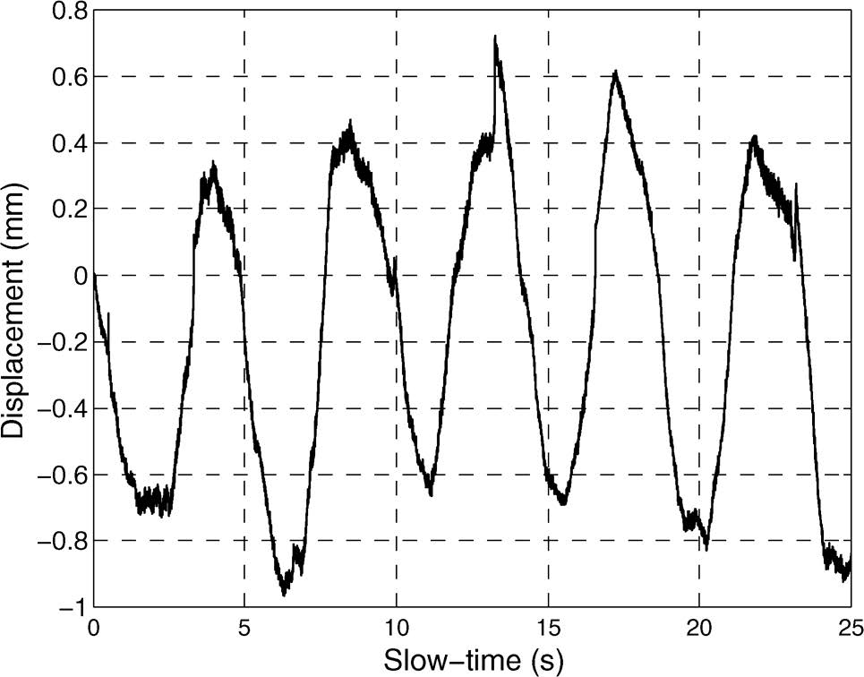

Fig. 2.10. Detected human respiration pattern [1]

By using the phase-based range-tracking algorithm mentioned in 2.3.4, minor movements of the human body can be detected. Fig.2.10 plots the measured human respiration detection result. The respiration rate of the subject was about 13 cycles/min and it is almost coinciding with the data measured by radar.

3.4.2 Indoor human tracking

Radar-based human tracking can be applied to indoor healthcare scenarios, such as fall detection of elderly people. Some portable FMCW radar prototype for indoor human tracking are presented [2][3]. The block diagram of the FMCW radar in [2] is shown in Fig. 2.11.

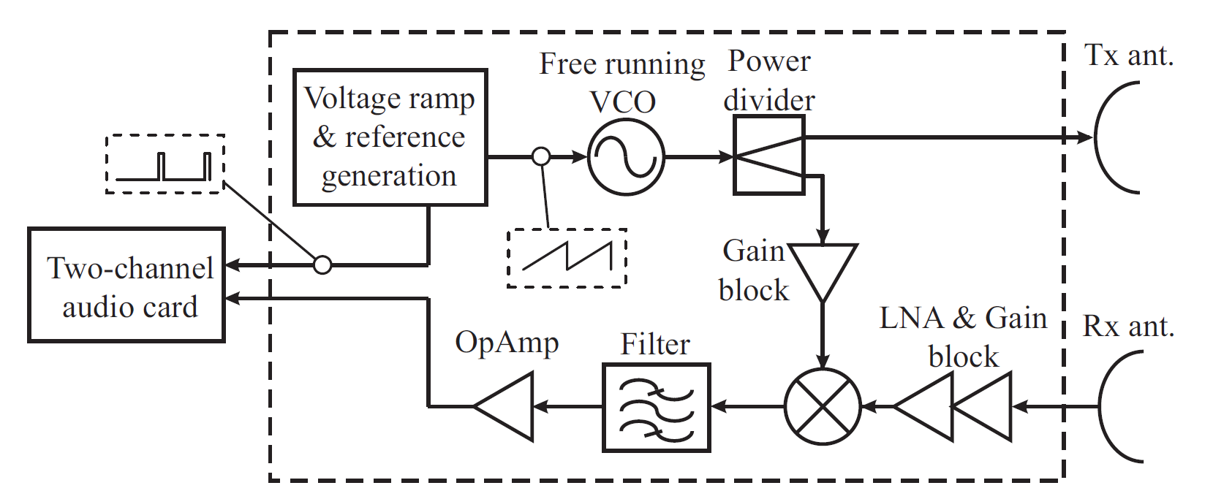

Fig. 2.11. Block diagram of the FMCW radar in [2]

The RX part proceeds with the mixing of a replica of the transmitted signal and the simultaneous sampling of the reference and baseband signals enables a correct formatting of the baseband-signal samples to construct the raw-data matrix, which guarantees the coherence of the system. Therefore, the system can preserve the phase history of targets and videos of inverse synthetic aperture radar (ISAR) images can be reconstructed.

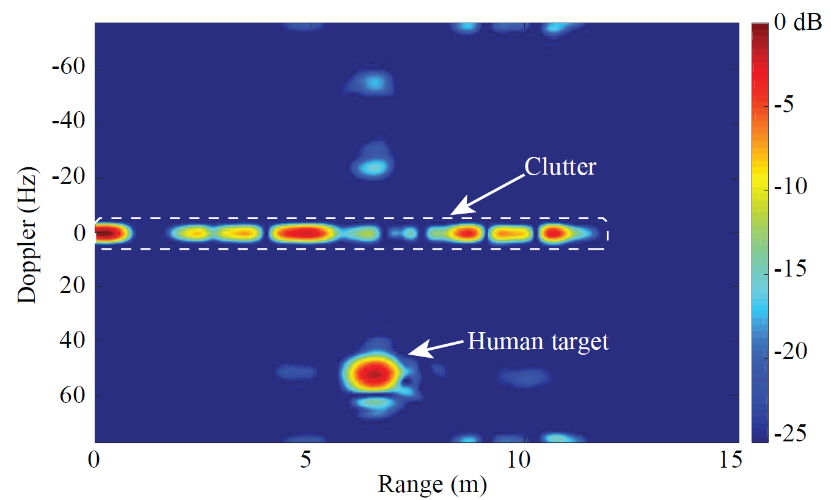

Fig. 2.12. ISAR frame of a human target [3]

Fig. 2.12 shows the range-Doppler frame of the human tracking experiment. The moving human target can be observed in this figure with the person’s Doppler frequency and range and the entire video can clearly complete the tracking of human targets.

3.4.3 Hybrid radar systems for human tracking and identification

Several hybrid radar systems that integrates the FMCW mode and interferometry mode have been published [4][5]. The FMCW mode is responsible for absolute range detection and the interferometry mode takes care of weak physiological movement monitoring.

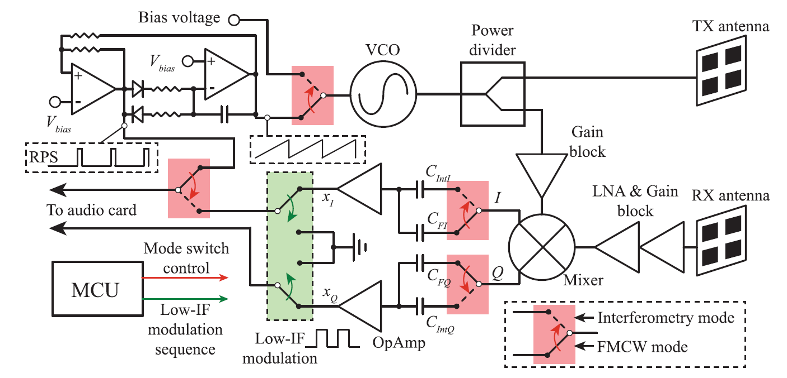

Fig. 2.13. Block diagram of the hybrid radar system in [4]

The block diagram of the FMCW interferometry hybrid radar system in [4] is shown in Fig 2.13. The two different radar modes share most of the RF components and signal paths and analog switches configured by an on-board microcontroller are used to select the operational modes.

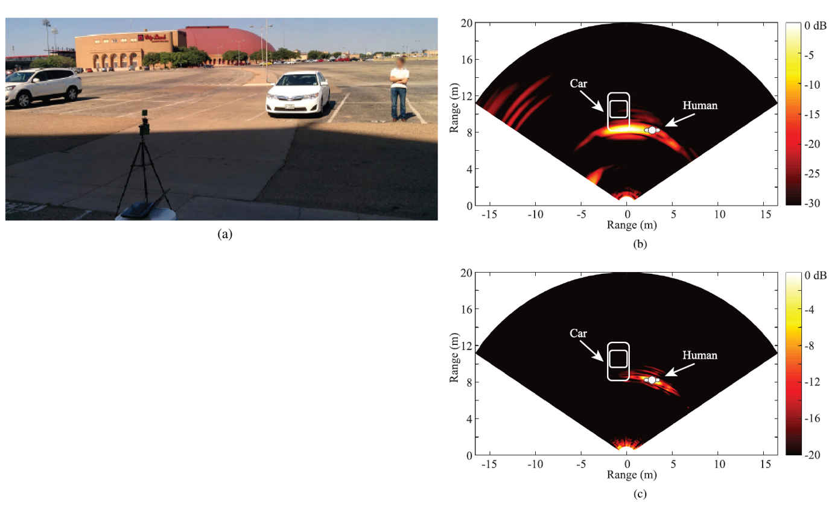

Fig. 2.14. Experimental setup and human target identification result [4]

The experiment setup for stationary target discrimination is shown in Fig.2.14(a). In this experiment, the human subject stood beside a parked car with a running engine. The proposed portable radar was mounted on a tripod to do a mechanical scan in the FMCW mode. Fig. 2.14(b) presents the 2-D mapping of the range profile. Because the frequency of car engine vibration is different from the frequency of human breathing, static objects can be discriminated by measuring images of several frames. Fig 2.14(c) is the 2-D mapping result for human target identification.

3.4.4 Other types of FMCW radar vital signs detection applications

A PCB realization of a K-band portable FMCW radar with beamforming array is presented [6]. It demonstrated an alternative approach to achieve portable and low-cost beamforming array radar systems with vector controllers and a six-port circuit. Range-gating and beamforming techniques allow the signal of interest to be isolated from surrounding clutter [7].

In addition, some companies such as Texas Instruments, Infineon, and Calterah have developed a series of FMCW radar products [8], and these products have greatly contributed to the development of vital sign monitoring using FMCW radars. Fig. 2.15 shows the Infineon’s BGT60TR24B Radar Sensor. It is a short range 60 GHz radar sensor with FMCW and Doppler-interferometric two modes. Fig. 2.16 shows the CALTERAH’s CAL60S244-IB radar sensor. It is a 4T4R 60GHz FMCW Radar with antenna array embedded in the package.

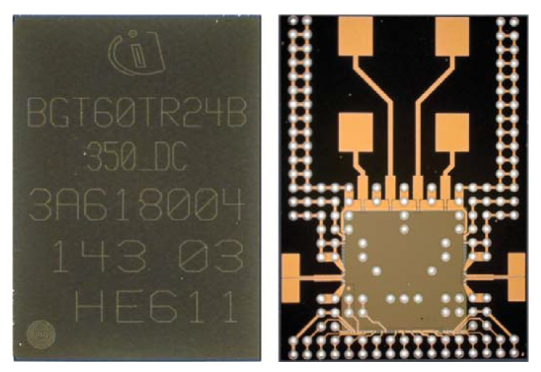

Fig. 2.15. Infineon’s BGT60TR24B Radar Sensor

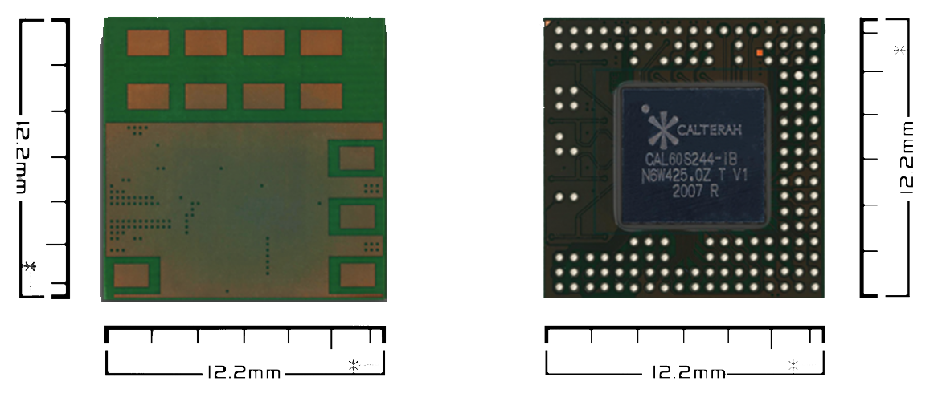

Fig. 2.16. CALTERAH’s CAL60S244-IB 4T4R 60GHz Radar SoC AiP

s

1. conclusion

This chapter summarizes the basic theory and the signal processing algorithms of FMCW/ CW radars. On that basis, several application examples of FMCW/ CW radars in contactless vital sign monitoring are introduced, including cardiopulmonary monitoring, human gait recognition, cancer medical application，and indoor human tracking. With the advantage of high integrability, strong environmental adaptability, low power consumption, penetrability, FMCW/CW radars have wide application prospects in our lives, contactless vital sign monitoring is one of the important aspects.

[H2 Title]

*** Insert Figure x.x ***

Caption:

Credit:

References

[1] Wang, X. Wang and et. al. “Noncontact Distance and Amplitude-Independent Vibration Measurement Based on an Extended DACM Algorithm,” *IEEE Trans. on Instrumentation and Measurement*, vol.63, no. 1, 2014.

[2] S. Kim and C. Nguyen, “On the development of a multifunction millimeter-wave sensor for displacement sensing and low-velocity measurement,” *IEEE Trans. Microw. Theory Tech.*, vol. 52, no. 11, pp. 2503–2512, Nov. 2004.

[3] B. Park, O. Boric-Lubecke, and V. M. Lubecke, “Arctangent demodulation with DC offset compensation in quadrature Doppler radar receiver systems,” *IEEE Trans. Microw. Theory Tech.*, vol. 55, no. 5, pp. 1073–1079, May 2007.

[4] K. Itoh, “Analysis of the phase unwrapping problem,” *Appl. Opt.*, vol. 21, no. 14, p. 2470, Jul. 1982.

[5] F. Schadt, F. Mohr, and M. Holzer, “Application of Kalman ﬁlters as a tool for phase and frequency demodulation of IQ signals,” *in Proc. IEEE Int. Conf. Comput. Technol. Electr. Electron. Eng.*, Jul. 2008, pp. 421–424.

[6] Wei Xu, Changzhan Gu, Jun-da Mao, “Noncontact High-Linear Motion Sensing Based on A Modified Differentiate and Cross-Multiply Algorithm,” *IEEE MTT-S International Microwave Symposium*, 2020.

[7] F.-K. Wang, T.-S. Horng, K.-C. Peng, J.-K. Jau, J.-Y. Li, and C.-C. Chen, “Single-antenna Doppler radars using self and mutualinjection locking for vital sign detection with random body movement cancellation,” *IEEE Trans. Microw. Theory Techn.*, vol. 59, no. 12, pp. 3577–3587, Dec. 2011.

[8] T.Kao, Y.Yan, T.Shen, A.Chen and J.Lin, “Design and analysis of a 60-GHz CMOS Doppler micro-radar system-in-package for vital-sign and vibration detection,” *IEEETrans.Microw.TheoryTechn.*,vol.61, no. 4, pp. 1649–1659, Apr. 2013.

[9] A. D. Droitcour, O. Boric-Lubecke, V. M. Lubecke, J. Lin, and G. T. A. Kovacs, “Range correlation and I/Q performance beneﬁts in single-chip silicon Doppler radars for noncontact cardiopulmonary monitoring,” *IEEE Trans. Microw. Theory Techn.*, vol. 52, no. 3, pp. 838–848, Mar. 2004.

[10] B. K. Park, O. Boric-Lubecke, and V. M. Lubecke, “Arctangent demodulationwith DC offset compensation in quadrature Doppler radar receiver systems,” *IEEE Trans. Microw. Theory Techn.*, vol.55, no.5, pp. 1073–1079, May 2007.

[11] Chao-Hsiung Tseng, Yi-Hua Lin, “24-GHz Self-Injection-Locked Vital-Sign Radar Sensor with CMOS Injection-Locked Frequency Divider Based on Push–Push Oscillator Topology,” *IEEE Microwave and Wireless Components Letters*, vol. 28, no. 11, 2018.

[12] A. Singh et al., “Data-based quadrature imbalance compensation for a CW Doppler radar system,” *IEEE Trans. Microw. Theory Techn.*, vol. 61, no. 4, pp. 1718–1724, Apr. 2013.

[13] M. Zakrzewski et al., “Quadrature imbalance compensation with ellipse-ﬁtting methods for microwave radar physiological sensing,” *IEEE Trans. Microw. Theory Techn.*, vol. 62, no. 6, pp. 1400–1408, Jun. 2013.

[14] C. Gu, Z. Peng, C. Li, “High-Precision Motion Detection Using Low-Complexity Doppler Radar with Digital Post-Distortion Technique,” *IEEE Trans. Microw. Theory Techn.*, vol. 64, no. 3, March 2016.

[15] J.C. Lin, “Noninvasive microwave measurement of respiration,” Proceedings of the IEEE, vol. 63, no. 10, Oct. 1975.

[16] A.D. Droitcour, O. Boric-Lubecke, V.M. Lubecke, J. Lin, G.T.A. Kovac, “Range correlation and I/Q performance beneﬁts in single-chip silicon Doppler radars for noncontact cardiopulmonary monitoring,” *IEEE Trans. Microw. Theory Tech.*, vol. 52, no. 3, March 2004.

[17] C. Li, J. Lin, “Random body movement cancellation in Doppler radar vital sign detection,” *IEEE Trans. Microw. Theory Tech.*, vol. 56, no. 12, Dec. 2008.

[18] C. Gu, C. Li, J. Lin, J. Long, J. Huangfu, L. Ran, “Instrument-Based Noncontact Doppler Radar Vital Sign Detection System Using Heterodyne Digital Quadrature Demodulation Architecture,” *IEEE Transactions on Instrumentation and Measurement*, vol. 59, no. 6, June 2010.

[19] C. Gu, C.i Li, “Distortion analysis of continuous-wave radar sensor for complete respiration pattern monitoring,” *IEEE Topical Conference on Biomedical Wireless Technologies, Networks, and Sensing Systems*, Jan. 2013.

[20] W. Hu, Z. Zhao, Y. Wang, H. Zhang, F. Lin, “Noncontact Accurate Measurement of Cardiopulmonary Activity Using a Compact Quadrature Doppler Radar Sensor,” *IEEE Transactions on Biomedical Engineering*, vol. 61, no. 3, March 2014.

[21] J. Tu, T. Hwang, J. Lin, “Respiration Rate Measurement Under 1-D Body Motion Using Single Continuous-Wave Doppler Radar Vital Sign Detection System,” *IEEE Trans. Microw. Theory Tech.*, vol. 64, no. 6, June 2016.

[22] Michael Otero, “Application of a continuous wave radar for human gait recognition,” *Proc. SPIE 5809, Signal Processing, Sensor Fusion, and Target Recognition*, May 2005.

[23] S. B. Jiang, “Radiotherapy of mobile tumors,” *Semin. Radiat. Oncol.*, vol. 16, no. 4, pp. 239–224, Oct. 2006.

[24] S.B.Jiang,“Technicalaspectsofimage-guidedrespirationgatedradiation therapy,” *Med. Dosim.*, vol. 31, no. 2, pp. 141–151, 2006.

[25] C. Gu, R. Li, H. Zhang, A. Y. C. Fung, C.s Torres, S. B Jiang, C. Li, “Accurate Respiration Measurement Using DC-Coupled Continuous-Wave Radar Sensor for Motion-Adaptive Cancer Radiotherapy,” *IEEE Transactions on Biomedical Engineering*, vol. 59, no. 11, Nov. 2012.

[26] C. Gu, R. Li, C. Li, and S. B. Jiang, “A multi-radar wireless system for respiratory gating and accurate tumor tracking in lung cancer radiotherapy,” *in Proc. 33rd Annu. Int. Conf. IEEE Eng. Med. Biol. Soc.*, Boston, MA, Aug. 2011, pp. 417–420.